HTML-CSS PRACTICE 04

1. Let’s create a card like all images bellow

Resource in “card”

- State 1: not hover to the card



- State 2: hover to the card



1. Create a form like the design below

Resource: “form-pet”

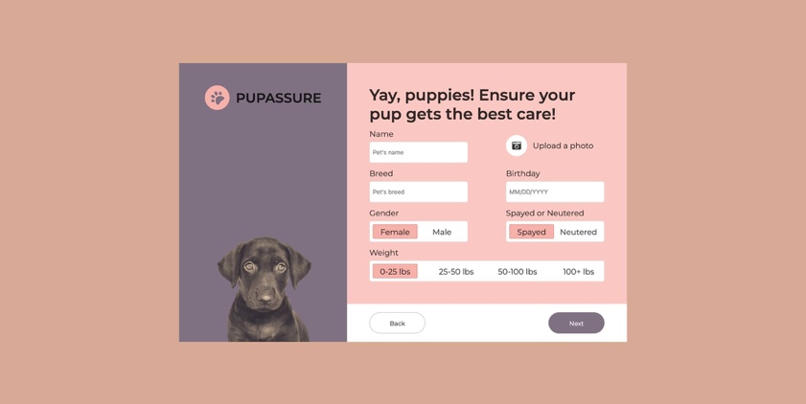

1. Create the memories card like the design bellow

Resource: “memories”

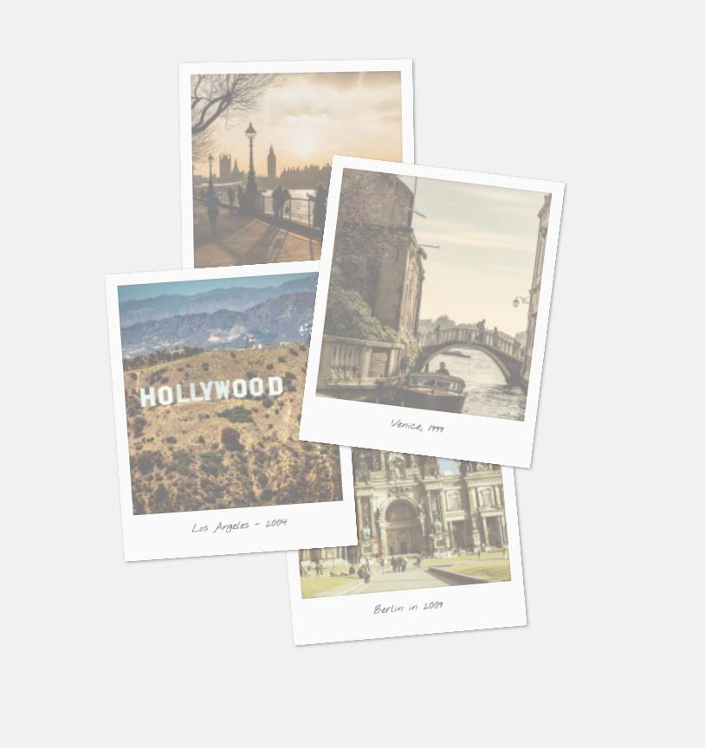

- Note that: When you hover to a card that will remove opacity in this card and rotate card straight by vertical